**Roll No**- 2019329

**Name** - Nikita Arora

**Q1: Create an HTML page with the sole purpose to show multiplication tables of 2 to 10 (row-wise) created by JavaScript. Initially, the page is blank. With help of set Interval function print a row every 5 seconds in different colors and increasing font size.**

**index.html**

<!DOCTYPE html>

<html lang="en">

<head>

    <meta charset="UTF-8">

    <meta http-equiv="X-UA-Compatible" content="IE=edge">

    <meta name="viewport" content="width=device-width, initial-scale=1.0">

    <title>Tables</title>

    <link rel="stylesheet" href="style.css"></link>

</head>

<body>

    <h1>Tables from 1 to 10</h1>

    <div id="parent">

        <table class="table" border="1">

        <tr id="display1">

            <td style="font-size: 30px;">1</td>

        </tr>

        <tr id="display2">

            <td style="font-size: 30px;">2</td>

         </tr>

         <tr id="display3">

            <td style="font-size: 30px;">3</td>

         </tr>

         <tr id="display4">

            <td style="font-size: 30px;">4</td>

         </tr>

         <tr id="display5">

            <td style="font-size: 30px;">5</td>

         </tr>

         <tr id="display6">

            <td style="font-size: 30px;">6</td>

         </tr>

         <tr id="display7">

            <td style="font-size: 30px;">7</td>

         </tr>

         <tr id="display8">

            <td style="font-size: 30px;">8</td>

         </tr>

         <tr id="display9">

            <td style="font-size: 30px;">9</td>

         </tr>

         <tr id="display10">

            <td style="font-size: 30px;">10</td>

         </tr>

        </table>

    </div>

    <script src="index.js"></script>

</body>

</html>

**index.js**

function table()

{

    if(i>=10)

        clearInterval(t);

    let colarr=["green","blue","green","red","magenta","brown","orange","purple","crimson","darkgoldenrod","grey"];

    let fontar=["10px","15px","20px","25px","30px","35px","40px","45px","50px","55px","60px","65px"];

    let display=document.querySelector("#display"+i);

    let newrow =document.createElement("tr");

    for(let j=1;j<=10;j++)

    {

        let mul=i*j;

        newrow.innerHTML+=`<td><b>${mul}</b></td>`;

    }

    newrow.style.color=colarr[i];

    newrow.style.fontSize=fontar[i];

    display.appendChild(newrow);

    i++;

}

let i=1,t;

function myfun()

{

    t=setInterval(table,1000);

}

myfun();

**style.css**

 body

 {

     background-color: cornsilk;

 }

 h1

 {

    color:darkred;

    text-align: center;

    font-family: Arial, Helvetica, sans-serif;

    text-decoration: underline;

 }

 .table

 {

    border: 10px solid navy;

    border-radius: 10px;

    display: block;

    border-collapse: collapse;

 }

 .table tr td

 {

    font-weight: bold;

    padding-right: 50px;

 }

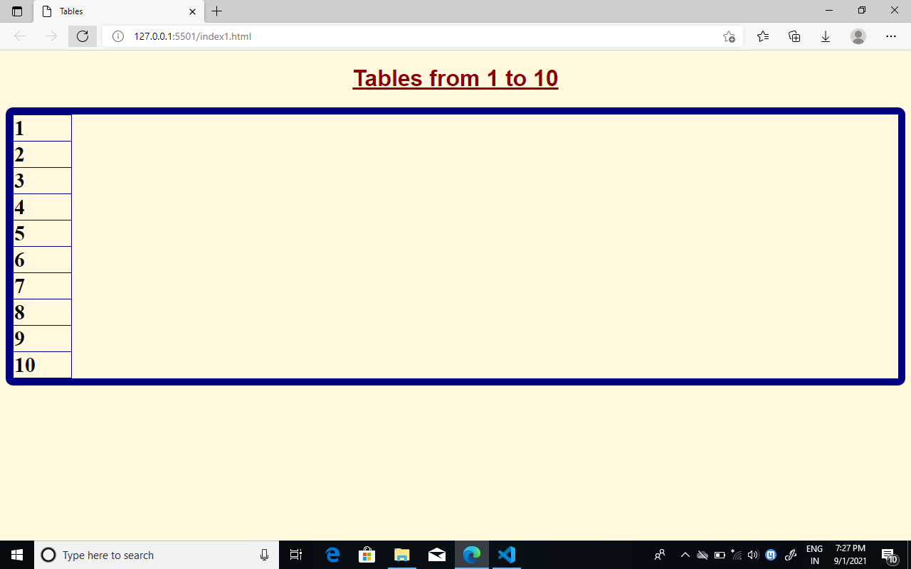

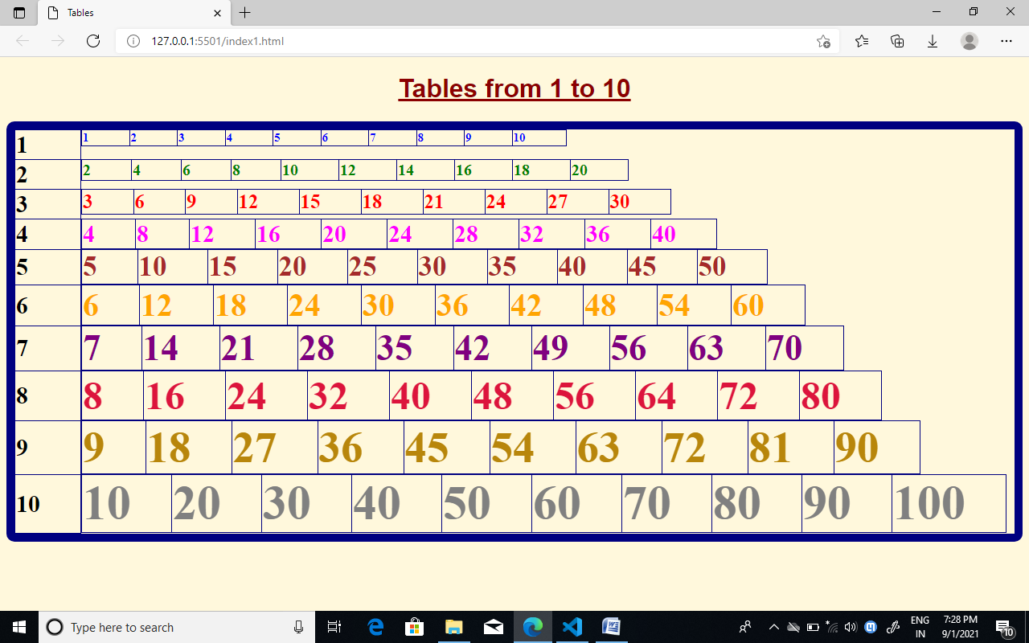

**Q2: Create an HTML page with a paragraph written on it and under which 9 buttons are placed in a 3X3 grid. The first row is for buttons labeled with colors names Red, Green, and Blue, the second row**

**with numbers 10, 20, 30, and the third row with different font names. Click event of each of the buttons should make the appropriate change in the style of paragraph.**

**index.html**

<!DOCTYPE html>

<html lang="en">

<head>

    <meta charset="UTF-8">

    <meta http-equiv="X-UA-Compatible" content="IE=edge">

    <meta name="viewport" content="width=device-width, initial-scale=1.0">

    <title>Events on button click</title>

    <link rel="stylesheet" href="style.css">

</head>

<body>

    <p id="p">

    Lorem ipsum dolor sit amet consectetur adipisicing elit.Sequi aliquam fuga aspernatur labore sit. Laudantium aspernatur, similique totam in, commodi fugit, sapiente nisi placeat nulla obcaecati exercitationem velit quae cupiditate.Lorem ipsum dolor sit amet consectetur adipisicing elit. Sequi aliquam fuga aspernatur labore sit. Laudantium aspernatur, similique totam in, commodi fugit, sapiente nisi placeat nulla obcaecati exercitationem velit quae cupiditate.Lorem ipsum dolor sit amet consectetur adipisicing elit. Sequi aliquam fuga aspernatur labore sit. Laudantium aspernatur, similique totam in, commodi fugit, sapiente nisi placeat nulla obcaecati exercitationem velit quae cupiditate.

    </p>

    <div class="container">

        <button type="button" class="r1" id="red" value="Red">Red</button>

        <button type="button" class="r1" id="green" value="Green">Green</button>

        <button type="button" class="r1" id="blue" value="Blue">Blue</button>

        <button type="button" class="r2" id="10" value="10">10</button>

        <button type="button" class="r2"id="20" value="20">20</button>

        <button type="button" class="r2" id="30" value="30">30</button>

        <button type="button" class="r3" id="Times New Roman" value="Times New Roman">Times New Roman</button>

        <button type="button" class="r3"id="sans-serif" value="sans-serif">Sans-serif</button>

        <button type="button" class="r3" id="monospace" value="monospace">Monospace</button>

    </div>

</body>

<script src="index.js"></script>

</html>

**index.js**

function fun1()

{

    paragraph.style.color=btnvalue1;

}

function fun2()

{

    paragraph.style.color=btnvalue2;

}

function fun3()

{

    paragraph.style.color=btnvalue3;

}

function fun4()

{

    paragraph.style.fontSize=btnvalue4 + "px";

}

function fun5()

{

    paragraph.style.fontSize=btnvalue5 + "px";

}

function fun6()

{

    paragraph.style.fontSize=btnvalue6 + "px";

}

function fun7()

{

    paragraph.style.fontFamily=btnvalue7;

}

function fun8()

{

    paragraph.style.fontFamily=btnvalue8;

}

function fun9()

{

    paragraph.style.fontFamily=btnvalue9;

}

var paragraph=document.getElementById("p");

var btn1 = document.getElementById("red");

var btnvalue1=btn1.value;

var btn2 = document.getElementById("green");

var btnvalue2=btn2.value;

var btn3 = document.getElementById("blue");

var btnvalue3=btn3.value;

var btn4 = document.getElementById("10");

var btnvalue4=btn4.value;

var btn5 = document.getElementById("20");

var btnvalue5=btn5.value;

var btn6 = document.getElementById("30");

var btnvalue6=btn6.value;

var btn7 = document.getElementById("Times New Roman");

var btnvalue7=btn7.value;

var btn8 = document.getElementById("sans-serif");

var btnvalue8=btn8.value;

var btn9 = document.getElementById("monospace");

var btnvalue9=btn9.value;

btn1.addEventListener("click",fun1);

btn2.addEventListener("click",fun2);

btn3.addEventListener("click",fun3);

btn4.addEventListener("click",fun4);

btn5.addEventListener("click",fun5);

btn6.addEventListener("click",fun6);

btn7.addEventListener("click",fun7);

btn8.addEventListener("click",fun8);

btn9.addEventListener("click",fun9);

**style.css**

p{

    margin: 20px;

}

.container

{

    width: 95%;

    margin: 0 auto;

}

.container button

{

    float: left;

    height: 50px;

    width: 30%;

    font-size: 30px;

    font-weight: bold;

    margin: 20px;

}

.container::after

{

    content: " ";

    display: block;

    clear: both;

}

.r1{

    background-color: lavender;

    color:midnightblue;

}

.r2

{

    background-color: papayawhip;

    color:purple;

}

.r3

{

    background-color:skyblue;

    color:darkblue;

}

